CSCI110 – Fundamentals of Computer Science

MT SAC College

CSCI110

Lab #: 6_________________

Description: ______________________

______________________

______________________

Due Date: 12/10/2021___________

Name: Austin Ngo______________

Grade: _______________________

Notes: ______________________

**Lab 6:**

/*

a. Program Description : This program takes a file named "babynames.txt" and takes the top 50% of babynames for boys and girls, then outputs it into a file named "output.txt".

b. Author : Austin Ngo

c. Input variables : babynames.txt

d. Process Flow : This program reads a file named "babynames.txt" then takes the top 50% popular babynames and outputs the results to a faile named "output.txt"

e. Output variables : output.txt

*/

#include <iostream>

#include <fstream>

#include <string>

using namespace std;

void process_name(ifstream& in_file, double& total, ofstream& out_file)

{

string name;

int count;

double percent;

in_file >> name >> count >> percent;

if (in_file.fail())

{

return;

}

if (total > 0)

{

out_file << name << " ";

}

total = total - percent;

}

int main()

{

ifstream in_file;

ofstream out_file;

in_file.open("H:\\babynames.txt");

if (in_file.fail())

{

return 0;

}

double boy_total = 50;

double girl_total = 50;

out_file.open("H:\\output.txt");

while (boy_total > 0 || girl_total > 0)

{

int rank;

in_file >> rank;

if (in_file.fail())

{

return 0;

}

out_file << rank << " ";

process_name(in_file, boy_total, out_file);

process_name(in_file, girl_total, out_file);

out_file << endl;

}

in_file.close();

out_file.close();

system("pause");

return 0;

}

**Lab 6A Test Cases:**

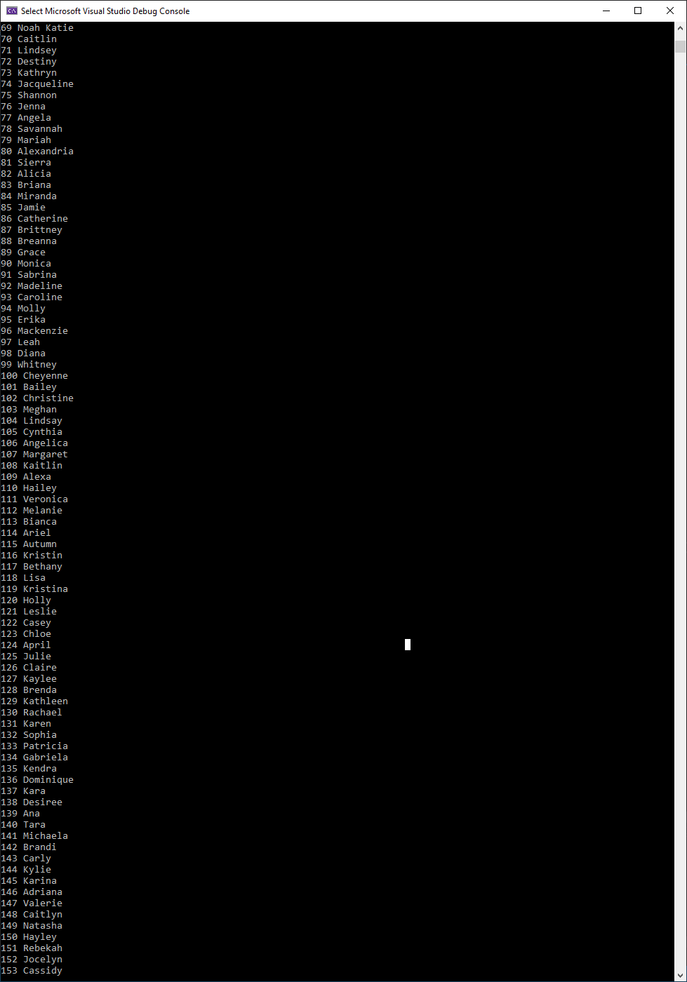

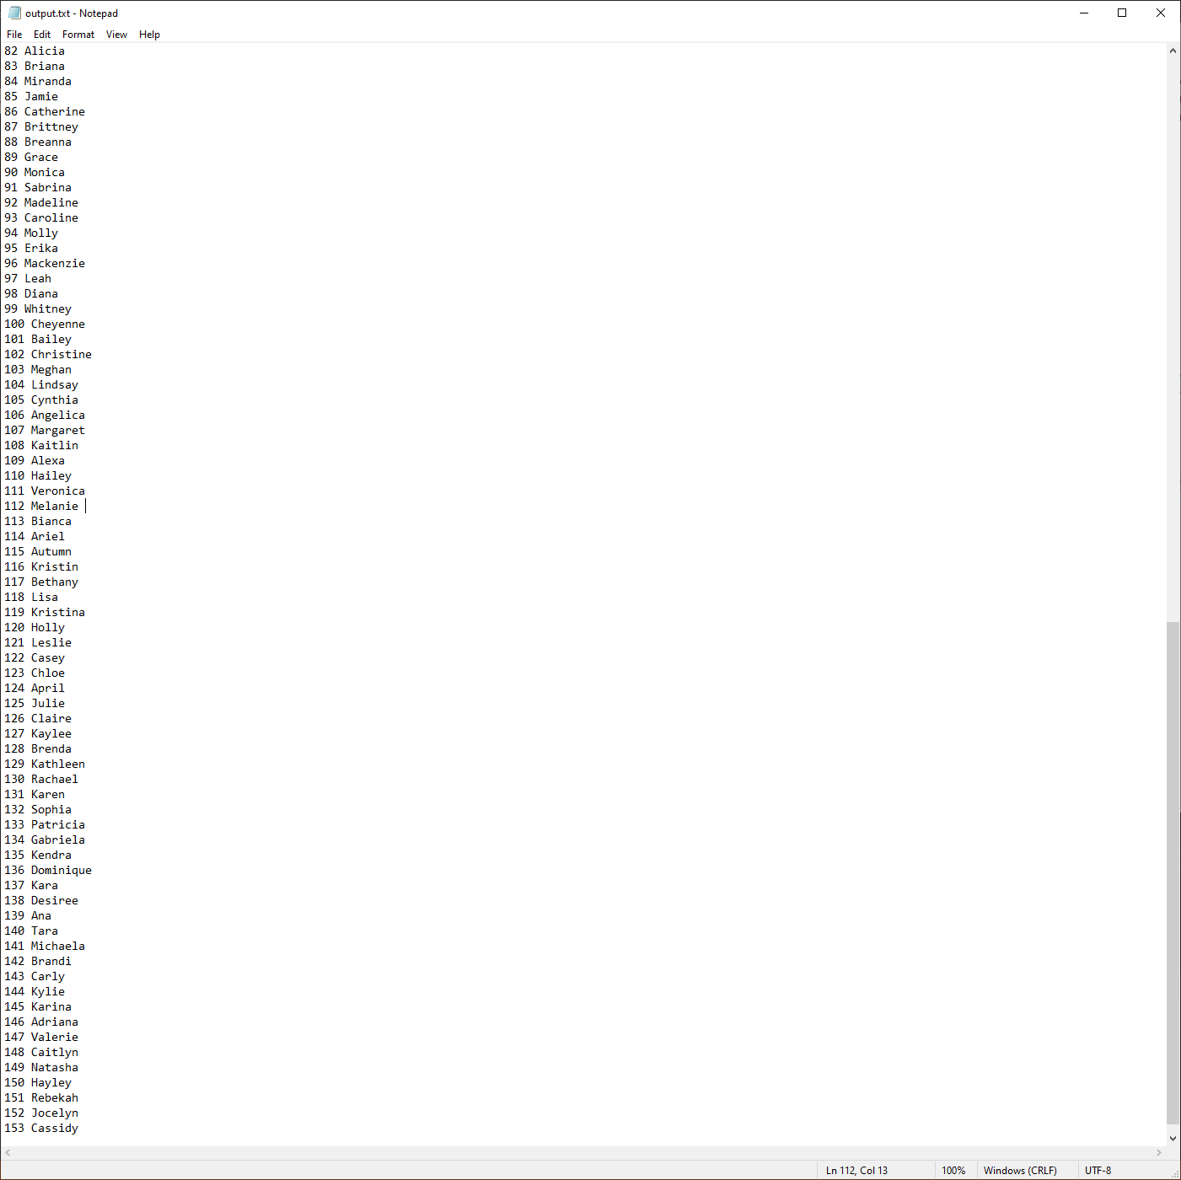

**Lab 6B:**

/*

a. Program Description : This program prompts the user for a filename, then reads and writes to the file, generating two columns of 10 random numbers ranging from 10-20, then outputs it to a file named "output.txt" which prints the two columns of numbers and the average of each column.

b. Author : Austin Ngo

c. Input variables : filename, n1, n2

d. Process Flow : Prompt user for filename, generate random numbers ranging from 10-20, write to input file, generate average, write to output file

e. Output variables : output.txt, average

*/

#include <iostream>

#include <string>

#include <fstream>

#include <cstdlib>

#include <ctime>

#include <iomanip>

using namespace std;

int main()

{

string filename;

cout << "Enter filename: ";

cin >> filename;

ofstream out_file(filename);

if (!out_file)

{

cout << "Error occured!\n";

exit(0);

}

srand(time(0));

float n1, n2;

for (int i = 0; i < 10; i++)

{

n1 = ((20 - 10) * ((float)rand() / (float)RAND_MAX)) + 10;

n2 = ((20 - 10) * ((float)rand() / (float)RAND_MAX)) + 10;

out_file << n1 << "\t" << n2 << "\n";

}

out_file.close();

ifstream in_file(filename);

if (!in_file)

{

cout << filename << " could not be read!\n";

exit(0);

}

ofstream faverage("H:\\output.txt");

faverage << setw(15) << "Number 1" << setw(15) << "Number 2" << setw(15) << "Average" << "\n";

float average;

cout << "File content:\n";

while (!in_file.eof())

{

in_file >> n1 >> n2;

if (in_file.eof()) break;

cout << setw(12) << n1 << setw(12) << n2 << "\n";

average = (n1 + n2) / 2;

faverage << setw(15) << n1 << setw(15) << n2 << setw(15) << average << "\n";

}

cout << "\nPairs with their averages are written to file output.txt\n";

faverage.close();

in_file.close();

return 0;

}

**Lab 6B Test Cases:**

